Anthony Meunier

DeVry University

CIS 355A

Week 4 iLab

Quick Fast Car Care Application

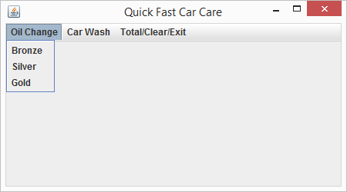

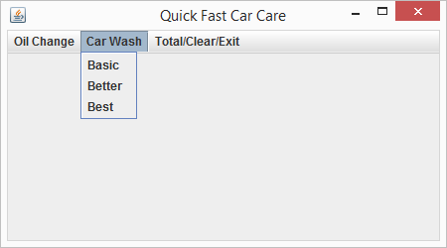

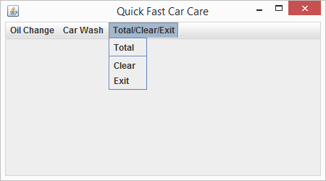

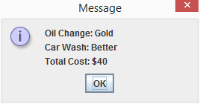

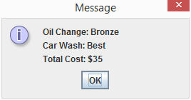

import java.awt.event.ActionEvent;

import java.awt.event.ActionListener;

import javax.swing.JFrame;

import javax.swing.JMenu;

import javax.swing.JMenuBar;

import javax.swing.JMenuItem;

import javax.swing.JOptionPane;

/***********************************************************************

Program Name: CarCare.java

Programmer's Name: Anthony Meunier

Program Description: CarCare class with Menus, MenuItems, Menubar, and so forth.

Uses appropriate event handlers.

***********************************************************************/

public class CarCare extends JFrame implements ActionListener { //Create class

//Attributes

private String oilChange = "";

private String carWash = "";

private int oilChangeCost;

private int carWashCost;

CarCare() {

setTitle("Quick Fast Car Care");

setSize(450, 250);

//Create a menubar for JFrame

JMenuBar menuBar = new JMenuBar();

//Add the menubar to the frame

setJMenuBar(menuBar);

//Define and add drop down menus to the menubar

JMenu oilChangeMenu = new JMenu("Oil Change");

JMenu carWashMenu = new JMenu("Car Wash");

JMenu fileMenu = new JMenu("Total/Clear/Exit");

menuBar.add(oilChangeMenu);

menuBar.add(carWashMenu);

menuBar.add(fileMenu);

//Create and add simple menu items to each one of the drop down menus

//Menu items for 'Oil Change'

JMenuItem bronzeAction = new JMenuItem("Bronze");

bronzeAction.addActionListener(this);

JMenuItem silverAction = new JMenuItem("Silver");

silverAction.addActionListener(this);

JMenuItem goldAction = new JMenuItem("Gold");

goldAction.addActionListener(this);

//Menu items for 'Car Wash'

JMenuItem basicAction = new JMenuItem("Basic");

basicAction.addActionListener(this);

JMenuItem betterAction = new JMenuItem("Better");

betterAction.addActionListener(this);

JMenuItem bestAction = new JMenuItem("Best");

bestAction.addActionListener(this);

//Menu items for 'Totals/Clear/Exit'

JMenuItem totalAction = new JMenuItem("Total");

totalAction.addActionListener(this);

JMenuItem clearAction = new JMenuItem("Clear");

clearAction.addActionListener(this);

JMenuItem exitAction = new JMenuItem("Exit");

exitAction.addActionListener(this);

oilChangeMenu.add(bronzeAction);

oilChangeMenu.add(silverAction);

oilChangeMenu.add(goldAction);

carWashMenu.add(basicAction);

carWashMenu.add(betterAction);

carWashMenu.add(bestAction);

fileMenu.add(totalAction);

fileMenu.addSeparator();

fileMenu.add(clearAction);

fileMenu.add(exitAction);

}

@Override

public void actionPerformed(ActionEvent e) { //actionPerformed method

//Functionality for 'Oil Change' selection buttons

if (e.getActionCommand().equalsIgnoreCase("Bronze")) {

oilChange = "Bronze";

oilChangeCost = 20;

} else if (e.getActionCommand().equalsIgnoreCase("Silver")) {

oilChange = "Silver";

oilChangeCost = 25;

} else if (e.getActionCommand().equalsIgnoreCase("Gold")) {

oilChange = "Gold";

oilChangeCost = 30;

//Functionality for 'Car Wash' selection buttons

} else if (e.getActionCommand().equalsIgnoreCase("Basic")) {

carWash = "Basic";

carWashCost = 5;

} else if (e.getActionCommand().equalsIgnoreCase("Better")) {

carWash = "Better";

carWashCost = 10;

} else if (e.getActionCommand().equalsIgnoreCase("Best")) {

carWash = "Best";

carWashCost = 15;

//Functionality for 'Total' button

} else if (e.getActionCommand().equalsIgnoreCase("Total")) {

int total = carWashCost + oilChangeCost;

String msg = "Oil Change: " + oilChange + "\nCar Wash: " + carWash;

JOptionPane.showMessageDialog(rootPane, msg

+ "\nTotal Cost: $" + total);

//Functionality for 'Clear' button

} else if (e.getActionCommand().equalsIgnoreCase("Clear")) {

carWashCost = 0;

oilChangeCost = 0;

oilChange = "";

carWash = "";

//Functionality for 'Exit' button

} else if (e.getActionCommand().equalsIgnoreCase("Exit")) {

System.exit(0);

}

} //End method

} //End class

**import** javax.swing.JFrame;

/***********************************************************************

Program Name: CarCareTest.java

Programmer's Name: Anthony Meunier

Program Description: CarCareTest class, which drives the application.

***********************************************************************/

**public** **class** CarCareTest { //Create driver class

**public** **static** **void** main(String[] args) { //Main method

CarCare carCare = **new** CarCare();

carCare.setDefaultCloseOperation(JFrame.***EXIT_ON_CLOSE***);

carCare.setVisible(**true**);

} //End method

} //End class